To summarize how Apple produces the data:

1. **Set A Baseline**

The baseline is the volume of directions requests per country/region, sub-region or city compared to a baseline volume on January 13th, 2020. Apple defines one day as midnight-to-midnight, Pacific time. Cities are defined as the greater metropolitan area and their geographic boundaries remain constant across the data set.

1. **Collect Data**

Starting from January 14th, 2020, data is generated by counting the number of requests by transportation type (drive, walk, transit, or ride), made to Apple Maps on iPhone, iPad, iPod touch**1**, and Mac (OS X 10.9 or later) **2** for directions in select countries/regions, sub-regions, and cities. In the data set, transportation type *ride* is not included. *Ride* is requested with a ridesharing app and is not available in all countries or regions.**3**If unavailable, Maps would display "Diections Not Available. No ride booking apps for your location are available from the App store." Users choose the transportation type and Tap Go to start navigation. When users start moving, Maps updates its position to give users a better sense of direction. To end navigation, users either tap End, then tap End Route or ask Siri to "Stop Navigating".

To generate a direction request, Apple uses methods of MKMapItem that send map items to the Maps app so that it can display them. Directions requests made using the MKDirections API are server-based and require a network connection.

There are no request limits per app or developer ID, so well-written apps that operate correctly should experience no problems.**4**

Location Services allows Apple to gather and use information based on the current location of user’s iPhone or Apple Watch to provide a variety of location-based services. To use these features, users must enable Location Services on their iPhones and give permission to each app or website before it can use the location data.

Location Services uses GPS and Bluetooth (where those are available) along with crowd-sourced Wi-Fi hotspot and to cell tower locations determine user’s device’s approximate location. If Location Services is on, iPhone will periodically send the geo-tagged locations of nearby Wi-Fi hotspots and cell towers (where supported by a device) in an anonymous and encrypted form to Apple, to be used for augmenting this crowd-sourced database of Wi-Fi hotspot and cell tower locations.**5**

1. **To Protect Privacy**

The data that is sent to Maps while users use the app — such as search terms, navigation routing and traffic information — is associated with random, rotating identifiers instead of their Apple ID so Apple doesn’t have a profile of individual movements and searches. The information collected is aggregated and aggregated data is considered non‑personal information for the purposes of this Privacy Policy. **6**

1. **Calculate**

The relative volume of directions requests by transportation type per country/region, sub-region or city compared to a baseline volume (equals to 100 in the dataset) is displayed in the dataset.

1. **Coverage**

Apple Maps has no demographic information about their users, so Apple can’t make any statements about the representativeness of usage against the overall population.

Transit feature is currently available only in some regions or languages. **7**

Transit is available on iPhone 5 or later, iPad Pro, iPad (5th generation or later), iPad Air or later, iPad mini 2 or later, and iPod touch (6th generation or later).**8**

1. **Others9**

Data for May 11-12 is not available and will appear as blank columns in the data set.

See gaps in the Figure below.

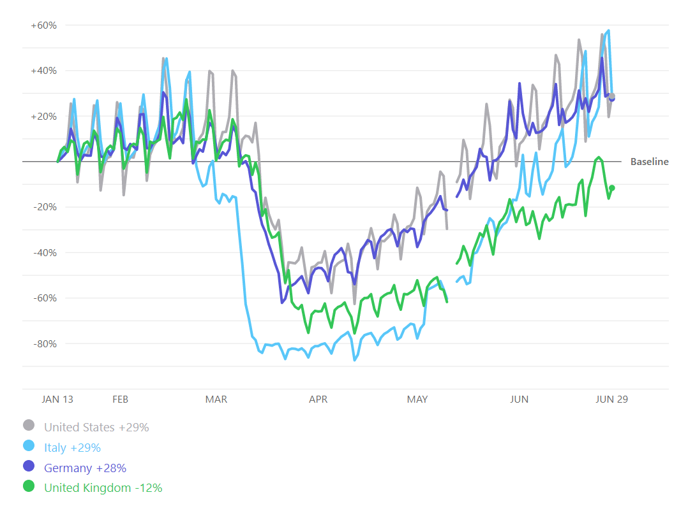

**OTHER REFERENCE**

About This Data, <https://www.apple.com/covid19/mobility>